Proposal Cover Sheet
Title of project proposal:
Project Team Leader: [Title, Name, Organization, Professional address, Email, Phone]

Additional Team Members:

Has this invention been disclosed to your Technology Transfer Office (TTO):
No_____ Yes_____ Contact person at TTO:____________________

SPARK Finland supports development of novel therapeutics, diagnostics, health technologies and health IT solutions for unmet medical needs. Any clinical indication will be considered. SPARK projects receive mentorship from experts, education in workshops on how to develop a solution and what you need to understand about business and finance. We might also have small sponsoring resources.

We accept applicants that are dedicated to advance their projects, meet our criteria and fit into our scope. We also accept applicants without own financial resources (for example Business Finland or research and innovation grants).

Proposals will be evaluated by an international panel of experts on three fundamental elements:
- Scope of unmet need in area of life science, medicine or health
- Novelty of approach
- Feasibility (point of maturity to be achieved within 2-3-year time frame)

Some examples of past projects in global SPARK programs include unmet needs in pediatric, neglected or orphan diseases, cardiovascular, oncology, inflammatory, respiratory, neurological, autoimmune indications and infectious disease.
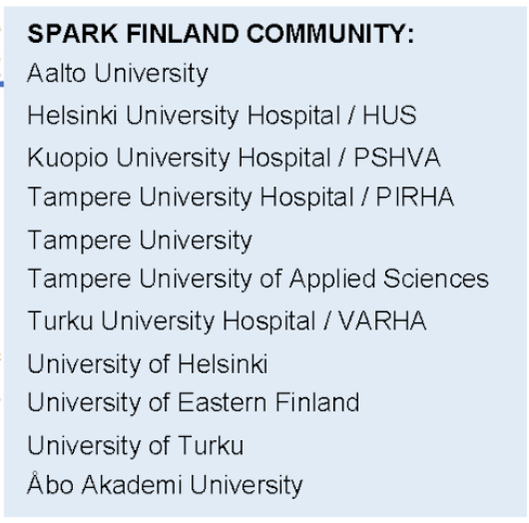
Eligibility:
Any Helsinki metropolitan area, Kuopio/Joensuu, Turku or Tampere region team (faculty, health care professional, postdoctoral fellow, or graduate student team) from our affiliated institutions is welcome to apply. The application must be co-signed by the project team or research group leader. Institutions that are members and/or associated with SPARK Finland are presented here.

Proposal components:
This cover page AND maximum 2 pages, at least 10 pt font
- Description of the ‘problem’ / medical need
- Description of your new solution / answer
- Difference to the current ‘Gold Standard’ / uniqueness of new solution
- Market niche and size (Europe and possibly other regions)
- Current development stage and future development plan
- Which part of your technology shall be patented?
- Applicant credentials (brief description of why the team is suitable to pursue this project)
- CV (not part of page limit)

Deadline: May 31st 2026 at 16:00 (EET)
Apply by sending an application in pdf format to apply@sparkfinland.fi .

